
The Leicestershire
End of Life Care
Handbook
For Adults with Learning
Disabilities
This Belongs To:

...............................................................
Date of Birth:
........................................................................................................

Edition 3 April 2013
For Carer’s and People with Learning Disabilities to discuss issues with End of Life
Contents

 | Page
- Introduction | 4
- Personal Choices | 5 - 13
- Family Wishes | 14 - 15
- Directory of Involvement | 16 - 18
- NHS Continuing Health Care | 19
- Care Checklist | 20 - 33
- Physical | 20 - 25
- Social | 26 - 27
- Psychological | 28 - 29
- Cultural Awareness | 30 - 32
- Spiritual | 33
- Physical and Psychological Changes at End of Life | 34 - 36
- Responsibilities at the Time of Death | 37
- Responsibilities after Death | 38 - 39
- Bereavement Support | 39 - 40
- Resource Information
- Making Decisions | 41 - 42
- Informed Consent | 43
- Advance Care Planning | 44 - 45
- Liverpool Care Pathway | 46
- Discharge from Hospital Checklist | 47 - 48
- Responsibilities after Death Checklist | 49 - 50
- Principles of a ‘Good Death’ | 51
- References | 52
- Disdat | 53
- DNACPR | 54 - 55
- Acknowledgements | 56

Introduction

End of life care is:
It can be very upsetting and shocking to be told that your loved one’s illness cannot be cured, and you both may need help and support to cope with this.
End of life care is support for people who are approaching death. It helps them to live as well as possible until they die, and to die with dignity.
- National Health Service 2013
It enables the supportive and palliative care needs of both patients and family to be identified and met through the last phase of life and into bereavement. It includes management of pain and other symptoms and provision of psychological, social, spiritual and practical support.
- National Council for Palliative Care 2011
This pack has been developed to be used by anyone who is caring for someone with a learning disability, who has a diagnosis of a life limiting condition such as Dementia or Cancer.
Supporting someone at the end of their life is always very difficult for all involved. Using this pack will help to gather information about the wishes of both the individual and their family, which will help to ensure a person centred approach to care and reduce the difficulty of having to ask the family to make lots of decisions at the time of their loved one’s death.
The pack also gives some specific care information with regards to the end of life as well as useful/practical information about what to do when a person dies.
Although traditional end-of-life care is defined as the last few weeks or days of life, this pack can be used from the point of diagnosis of a life limiting condition which will enable the individual enough time to be as fully involved as possible, early involvement is particularly important for individuals with Dementia who will sadly lose a lot of their skills and be unable to express their wishes so well as the condition progresses. Please see easy read version on the next page.

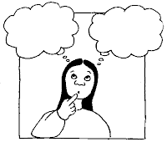
How this book will help you
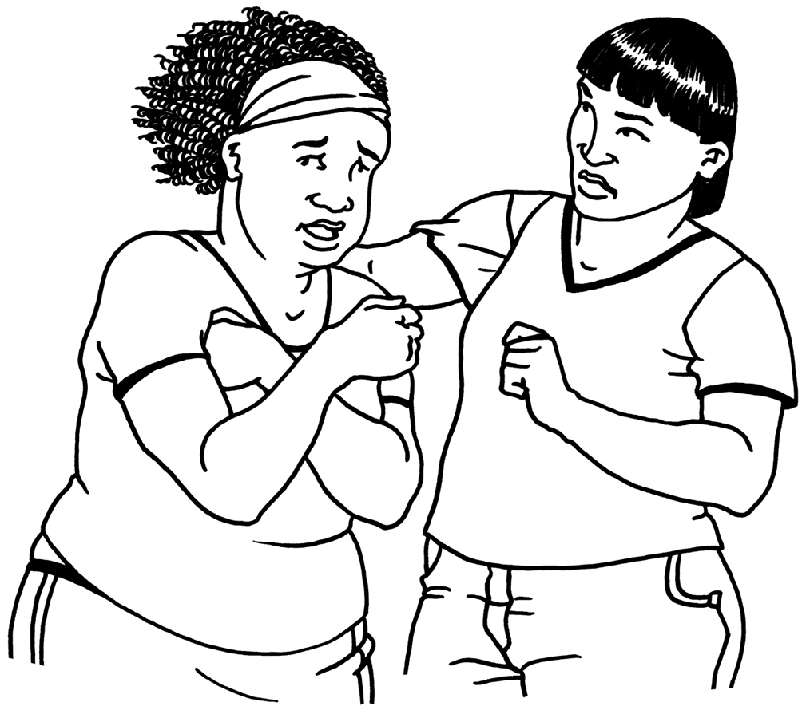
It can be upsetting to be told that you are very poorly and won’t get better. This is called a life limiting condition and can be things like dementia and cancer.

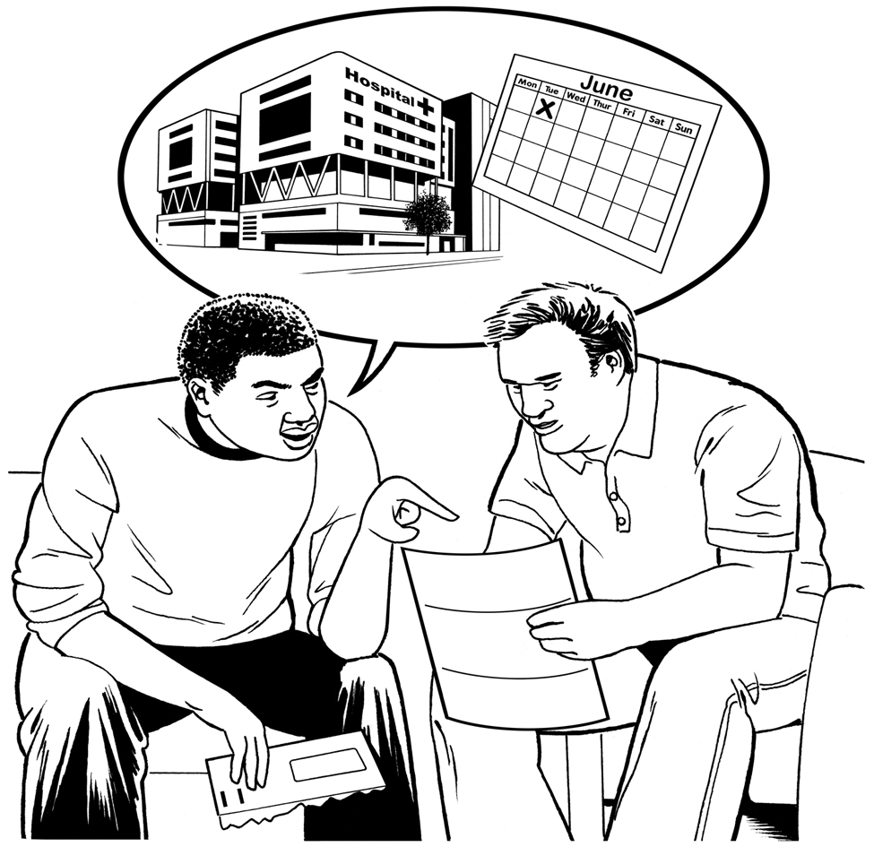

This book will help you to be involved in your care and who will care for you.



It is important that people know what is important to you and what you don’t like.

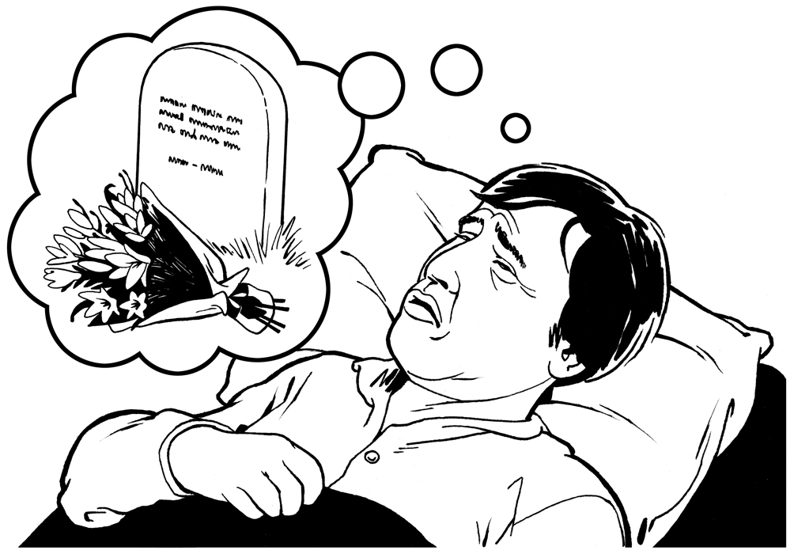
This book will help you to plan what you would like to happen when you die.

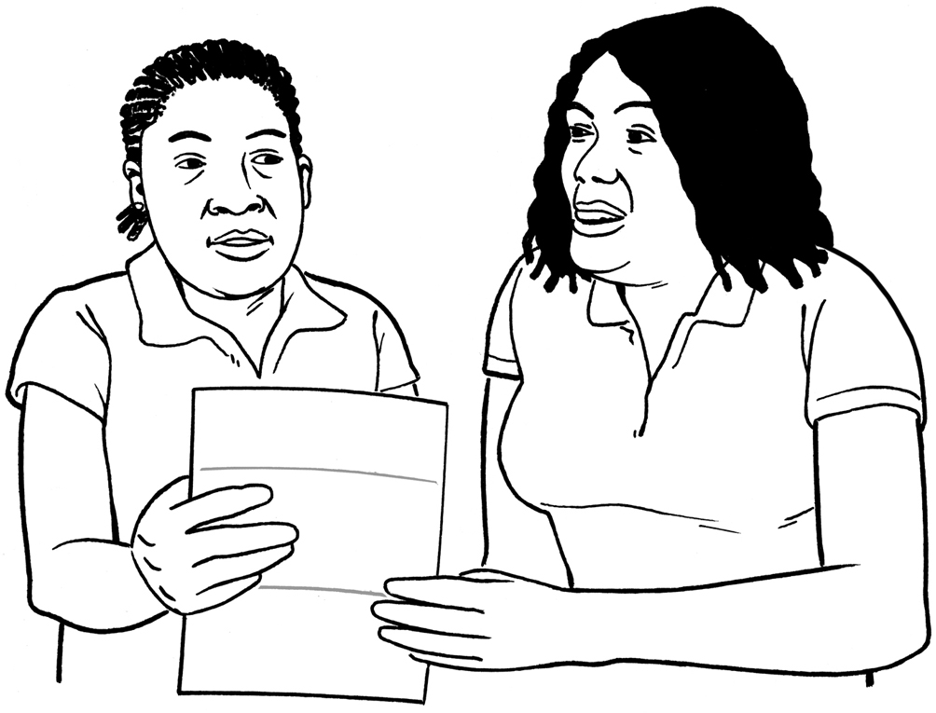

You can ask your Key Worker, Carer, Family or Health Worker to help you to write in this book.
Personal Choices

 | My name is: _____________________________  I like to be known as: ______________________  ________________________________________
 | I live at: _________________________________  Telephone Number ____________________
 | My important person to be contacted in an emergency is: ____________________________  ________________________________________
They live at: ______________________________

Telephone Number ____________________

Personal Choices

Personal Choices
These ideas are what I would like ______________

__________________________________________
 | I have made a Will __________________________  Yes  No  (Circle choice)  My will is kept with _________________________  Address: __________________________________  __________________________________________  __________________________________________  Tel:  _________________________________  I have registered as an Organ Donor:  Yes No (Circle choice)
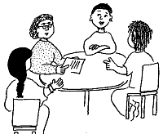 | This was a Best Interest Decision:  Yes No (Circle choice)  People involved in bringing this plan together were: ________________________________________  ________________________________________  ________________________________________  ________________________________________  ________________________________________
Key Worker involved is: _______________________________________

Tel: ___________________________________
Personal Choices

Personal Choices
 | Who else is important to me: _______________________________________  ________________________________________  ________________________________________
 | My religious / spiritual needs are: ________________________________________  ________________________________________  ________________________________________
 | Would I like to be cared for at home if I become very ill?  Yes No (Circle choice)  If not, I would like to go to ________________________________________  ________________________________________  ________________________________________
(See resource information for Advance Care Planning)

 | When I die ………………..
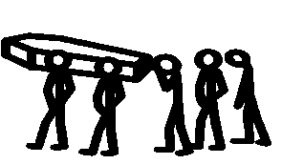 | I would like to be buried  Yes No (Circle choice)
 | I would like to be cremated  Yes No (Circle choice)
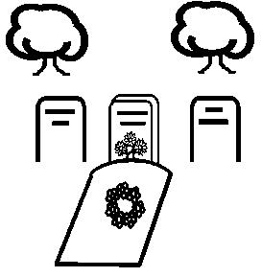 | I would like to be buried at: ___________________  I would like my ashes scattered at: ______________  My special place is: __________________________
Personal Choices
Personal Choices
 | My favourite flowers are: ____________________  I would like these flowers at my funeral:  Yes No (Circle choice)
 | My favourite song, or type of music is: _________  _________________________________________  I would like this music at my funeral:  Yes No (Circle choice)
 | My favourite piece of reading is: ______________  _________________________________________  I would like this to be read at my funeral:  Yes No (Circle choice)

 | Are there any things which you don’t want at your funeral? ___________________________________  ___________________________________________
 | Do you have any items that are really important to you? ______________________________________  ___________________________________________
 | Would you like to have any of these items in your coffin with you?  Yes No (Circle choice)  Things I would like in my coffin with me are: ______  ___________________________________________  ___________________________________________  ___________________________________________  ___________________________________________

Personal Choices

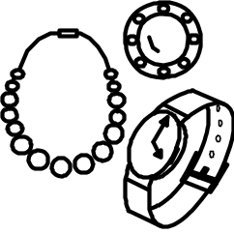 | Would you like someone to have these important items?  Yes No (Circle choice)  I would like my important things to go to: ________  ___________________________________________  ___________________________________________  ___________________________________________
Is there anything else which is important for your
carers to know? ___________________________________________
___________________________________________

___________________________________________

Personal Choices can be made into a formal decision by calling them Advance Care Plans (see page 44). Don’t forget to use the Person Centre Plan/Communication Passport if the individual has them.

This is not a legally binding document. If decisions to refuse or accept treatment are needed, see flow chart on page 45.

Family wishes
Next-of-kin

Address &
Telephone number

Any other family members who
should be contacted

Religion/faith/spiritual needs

Do you know if your loved one has specific wishes about personal belongings?

Any specific requests with
regards to death rites

Where would you like your loved one to be cared for in their last days of life?

Preferred undertaker

Who would you like to help you to make funeral arrangements?

Cremation or burial

Place of internment?
Family plot, cemetery, scattering ashes?

How will funeral be paid for?

What sort of plans should be made after funeral (wake)?

Who should be involved in funeral and wake?

Any other details which need to be recorded? E.g. – will, advance directives?

 | Name | Contact Details | How I will help
GP

Psychiatrist

Community LD
Nurse

Occupational Therapist (OT)

Physiotherapist

Speech & Language Therapist
(SALT/SLT)

Psychologist
District
Nurse
(DN)

Macmillan Nurse

Hospice at home (H@H)

Social
Worker
(S/W)

Advocate

Carers Association

Bereavement Service

Clergy

Funeral Director

Pharmacist

Dietician
Nottingham Rehabilitation
Service

Rapid Intervention
Team

Continuing Health Care

Directory of Involvement

Useful numbers
University Hospitals of Leicester ............................................................ 0300 030 1573
Out of hours GP………………………………………………………………………………… 0845 045 0411
Hospice at Home (9am-5pm Mon-Fri) .................................................. 01509 410395
Hospice at Home (5pm – 9am) .............................................................. 0300 3007777
Loros Hospice ................................................................................... .. 0116 2313771
NHS Direct ........................................................................................... 0845 4647

What is NHS continuing healthcare?
NHS continuing healthcare is the name given to a package of care which is arranged and funded solely by the NHS for individuals outside of hospital who have ongoing healthcare needs. You can receive continuing healthcare in any setting, including your own home or a care home. NHS continuing healthcare is free, unlike help from Social Services for which a financial charge may be made depending on your income and savings.
Who is eligible for NHS continuing healthcare?
Anyone assessed as having a certain level of care needs may receive NHS continuing healthcare. It is not dependent on a particular disease, diagnosis or condition, nor on who provides the care or where that care is provided. If your overall care needs show that your primary need is a heath need, you should be eligible for NHS continuing healthcare. Once eligible for NHS continuing healthcare, your care will be funded by the NHS but this is subject to review, and should your care needs change the funding arrangements may also change.
Whether someone has a ‘primary health need’ is assessed by looking at all of their care needs and relating them to four key indicators:
Nature.
Complexity.
Intensity.
Unpredictability.
How are the decisions made about who is eligible for NHS continuing healthcare?
The whole of the decision making process should be ‘person centred’. This means putting the individual and their views about their needs and the care and support required at the centre of the process. It also means making sure that the individual plays a full role in the assessment and decision making process and gets support to do this where needed. This could be by the individual asking a friend or relative to help them explain their views, also advocacy support services may be able to assist.
Contact Details - A continuing healthcare team now live at St Johns House. Public 0116 2951400
Further information https://www.gov.uk/government/publications/nhs-continuing-healthcare-and-nhs-funded-nursing-care-public-information-leaflet
NHS Continuing Healthcare

Symptoms | Tips to Help
Pain  Depending on the condition which the individual has there may be a certain amount of associated pain, especially with cancer. Someone who has a learning disability or who is extremely ill may not be able to express their level of pain, it is therefore very important that all carer’s look for non-verbal signs of pain. You can use tools such as the DisDat Tool to assess when people cannot tell you about it. See Resource section for tool. | Sometimes repositioning the individual can relieve discomfort but if you are concerned that the individual is suffering from pain then it is important that this is discussed with the GP or Palliative Care Team as soon as possible. There are a variety of effective analgesic medications which can be given in a variety of ways. You should also consider other things that might cause pain, such as a not being able to pass urine, which can be treated quickly and reduce the need for strong pain medication.  Common analgesic medications are Morphine and Fentanyl (opiates).
Nausea and Vomiting  Nausea and vomiting frequently occurs as the individual nears the end of life. The most common causes are medication, the disease itself and changes to the body’s chemistry as organs stop working properly. People can experience nausea without vomiting and can vomit without feeling long periods of nausea. | To help people with nausea and vomiting we can make sure we keep strong smells to a minimum, for example strong cooking smells and perfume. Fizzy drinks and ginger preparations can reduce the feeling of nausea. Hypnotherapy and acupuncture may help. As nausea reduces a person’s appetite  offer small, light meals but don’t be  distressed if they don’t want to eat. Food supplements might be useful.  There are many different types of medication for nausea and vomiting, (anti-emetics), the most common ones are Haloperidol, Nozinan, (Levomepromazine), and Cyclizine.
Care Checklist Physical

This section has highlighted the main physical symptoms the person may encounter towards the End of Life providing tips on how to manage these symptoms. The individuals Health Action Plan will need to be reviewed to make sure their existing health conditions are not forgotten.
For further information please see Resource Information – Liverpool Care Pathway

Physical
Symptoms  Restlessness and Agitation  As the individual becomes more poorly they may seem disorientated and confused. This may develop into delirium or agitation. The individual may speak or shout out in a way which makes no sense, they may push anyone away or their arms and legs may flail out. Some people become frightened. | Tips to Help  Good communication is really important and even when it is thought that the individual can no longer hear or understand it is still important to speak to them, explain all aspects of care and give reassurance. Be aware of how the individual communicates e.g. pictures, objects of reference. If comfort and reassurance is not effective medication may be required.  The most common medication used is Midazolam.
Continence  The individual will need full support with meeting all their continence needs. Sometimes the individual may retain urine which will result in a distended, (swollen), bladder and discomfort. With respect to the bowels there could be either constipation or diarrhoea, both of which could lead to discomfort. | Ensure high levels of personal care to refresh soiled/wet pads as necessary and meet personal hygiene needs. If there are signs of urine retention then seek medical advice as it may be appropriate for a catheter to be inserted. If there are signs of either constipation or diarrhoea then you should also get advice.
Weakness/Drowsiness  As the individual nears the end of life they will become increasingly weak and fall in and out of sleep. This is a natural part of the process as the body begins to shut down. | It is important to maintain all aspects of care but as the individual will tire easily it may be beneficial to breakdown tasks into smaller tasks and allow the person to rest in between.
Risk of skin breakdown  As the individual becomes less mobile their skin is at greater risk of developing pressure sores. The individual’s skin may look and feel differently as they near the end of life. Skin can be clammy and look pale or blotchy. Facial features may appear gaunt and feet/hands may feel very cold. | High standards of personal care will help to maintain the integrity of the skin. Being clean, dry and warm will help to minimise the risk of developing pressure sores and regular repositioning of an individual when they become immobile will also help. The District Nurse can give advice on appropriate pressure relieving cushions and mattresses.

Symptoms  Decreased Oral Intake  It is quite normal for someone to stop eating and drinking as they are nearing the end, they no longer want or need it. However, it is important to realise that nausea and vomiting could be the cause of reduced oral intake. There may also be problems taking medication. | Tips to Help  As the appetite decreases try tasty snacks, little and often of favourite foods. Do not try to feed a person who does not want to eat or is having difficulty swallowing. Giving individuals food or fluid artificially is unlikely to be of benefit, and may cause discomfort. It will most likely be discontinued as a person approaches the end of life.
Dry/ Sore Mouth  The reduced intake of food or fluids may result in the individual having an extremely dry mouth. Individuals often develop a general soreness in their mouth as well. Infections such as oral thrush may also develop. | Even though the individual may not want to drink it is important to moisten and freshen the mouth, this can be done with sponges or gauze swabs, crushed iced or sips of fluid, consider using lip balm on dry lips. Teeth should be cleaned regularly using a soft brush. Ask the care team or GP about mouthwashes and gels that can be used. Sucking pineapple chunks or kiwi fruit can help clean and freshen the mouth.
Risk of Falls  As individuals become weaker they may become prone to falls. This can be due to the disease itself, medication or weakness due to poor dietary intake. | An assessment can be requested from your District Nursing team who can provide equipment to help minimise the risk of the individual falling. Referrals may be made to the GP for a review of medication or physiotherapists/occupational therapists for specialist advice on reducing the risks of falls.

It is vital to take account of how the individual feels about their symptoms and how they want them managed.
Physical

Be aware that cultural and religious issues may impact on symptom management.
Physical
Medication at End of Life

When it is recognised that an individual is in the last few days or hours of life it is usual for the doctor to review any medication that the patient is prescribed and to discontinue any that are no longer going to be of benefit. These include medications such as vitamins, statins (for cholesterol), anti-biotics and iron. All medications that will provide comfort and relief of symptoms will be continued.

The doctor may prescribe medication for symptoms that the individual is not experiencing now but might experience as their condition progresses. This is called pre-emptive prescribing and means that if uncomfortable symptoms develop the nursing team can treat the individual straight away, avoiding any delays by having to wait for a doctor to call.

Syringe Drivers

When a person is no longer able to swallow medication because of nausea, weakness or unconsciousness the doctor and care team may prescribe medication to be given through a syringe driver. This is a small, portable pump that will give a person continuous medication over a twenty-four hour period. The team may also insert a small needle with a short tube just under the skin to administer medication; This is called a ‘Butterfly’. The Butterfly and the syringe driver may be used alone or together and are very effective ways of keeping symptoms controlled without the individual having to have a lot of injections.

Complimentary Therapy

Complimentary Therapy can be used in conjunction with medical treatments to help with symptoms such as pain, anxiety, nausea and breathlessness. Popular Complimentary Therapies include Aromatherapy, Massage, Acupuncture, Head Massage, Reflexology and Hypnotherapy. These treatments are not generally available from the NHS but can be provided by organisations such as LOROS and Coping with Cancer.

Physical
Do Not Resuscitate
When someone has a diagnosis of a life limiting condition and they are in the final stages of the illness, it is unlikely that resuscitation would be successful. If it were successful then is it likely that the person would die soon after. It is felt that the trauma caused for both the individual and those involved in trying to resuscitate is far greater than the likelihood of success.
In hospital the doctor possibly responsible for the patient will often make the decision that resuscitation is not recommended, after possibly speaking to relatives and the individual, a ‘DNA-CPR’ (Do Not Attempt Cardio-Pulmonary Resuscitation) will then be put in place. If the individual is discharged home to die or is in the community when they reach the end stage of life then it is the responsibility of the GP to make the decision about resuscitation.
The DNA-CPR form needs to remain with the individual when crossing through services.
When your loved one gets a diagnosis of a life limiting condition and they are in the final stages of the illness, it is unlikely that resuscitation would be successful. If it were successful then is it likely that the person would die soon after. It is felt that the trauma caused for both the individual and those involved in trying to resuscitate is far greater than the likelihood of success.
It is the responsibility (irrelevant of care setting) of the individuals Doctor, or appropriately trained nurse, to complete a DNA-CPA form if resuscitation is not felt to be successful. The clinician is then advised to discuss this decision and issues arising from resuscitation, with your loved one and yourself. Once the form is completed, the original will be given to the individual and relevant people will be informed of the decision.
A DNA-CPR form solely applies to cardiopulmonary resuscitation, meaning that when your loved one’s heart stops or they stop breathing, there will be no invasive procedure to restart the heart or breathing. Any other treatments that your loved one may require will be discussed as they arise.
The original signed and dated DNA-CPR form should be kept with the individual when moving through their journey. The DNA-CPR form applies across the entire East Midlands healthcare community, in all settings, including whilst in ambulance transfers.
East Midlands Strategic Health Authority (2011)
Leicestershire Partnership NHS Trust Resuscitation Policy (2012)

Physical
al
Out of hours
Planning is essential in trying to avoid a crisis occurring ‘Out of Hours’ when the professionals who have been involved with the individual are not available.
If a person becomes suddenly ill at night or at weekends then the on-call doctor may not be aware of the plans which have been made with regards to the ‘preferred place of care’ it may result in an emergency admission into hospital which is often not what the person or their family want.
By careful planning and early involvement of appropriate palliative care teams then care needs can be better predicted and provision made to meet needs regardless of when needs change.
Pharmacy
It may sometimes be difficult to obtain prescribed medication specific to palliative care. Make a note of the opening hours of your local pharmacy, your nearest out of hours service and whether your local pharmacy can order non-stock items quickly.
Discharge from Hospital
Before being discharged from hospital, especially if a person has palliative care needs, there are several questions to be considered before the individual comes home.
(see checklist in resource information Page …….

Social
Relatives / Family
It is important for the individual and their family to spend time together towards the end. If possible there should be flexible visiting arrangements and the opportunity to have private time together in a suitable environment.
Friends
Friends should also be allowed to visit. In a care home setting, even though an individual may be bed- ridden towards the end, their friends who they have lived with should be supported to visit at appropriate times, to sit with them. This will both support the individual who is dying and the friends when it comes to coping with bereavement. It may be appropriate to leave the bedroom door open at times so that the individual feels less isolated and involved in the general surroundings of the home if possible.
Communication
It is vitally important that good communication is maintained with all involved, at all times, to ensure that the wishes of both the individual and their loved ones are met. It may be appropriate to use communication aids, such as objects of reference to assist in achieving effective communication. Speech and Language Therapists can help with this. Good communication is also important to ensure high standards of care.
Financial
Consideration should be given to the financial status of the individual. If there is likely to be a financial problem in paying for funeral expenses or a significant sum of money left, then it would be good practice to discuss this with relatives to prevent them having to make difficult decisions at the time of death. It may be useful to set up a separate account or set aside some money each month once the diagnosis of a life limiting condition has been diagnosed.

Social

Personal belongings
You need to check if the individual has written a will. If they have not it may be appropriate to discuss this at an early stage as they may like to have a say on what happens to their belongs after their death, there may be some jewellery or special items which they would like to give to a friend or relative. If this is the case then it is important to record this and discuss with relatives even if an actual will is not made.

Refer to Person Centred Plan, if in place.

Psychological
Dignity & Privacy
Carers should remember right to the end, even though an individual may not be very responsive or able to do much for themselves, that they are still a human being with feelings. Staff should care for them as if they are still able to be fully involved in making choices, and hear and understand everything which is being said. Carers should use speech throughout all aspects of care to explain to the individual what they are about to do to fully involve them. Carers should also maintain privacy by ensuring the individual is suitably covered and the door is shut for personal care. Carers should also be mindful that care settings can often be very noisy or busy and the dying person should be protected from this.
Personal Care
When it comes to personal care the fine details should be remembered. Someone who was very proud of their personal presentation, had always had neat hair, for example, should be supported to look their best. Ensuring that their hair is brushed, nails are tidy and skin is moisturised could help to make a person feel a little better, would this matter we should always make an effort.

Psychological
Talking about death
It is not easy to talk about issues relating to death but it is important to be honest and difficult subjects should not be avoided. The individual has a right to know about their condition and that they are dying and all efforts should be made to enable them to understand this. It is also important that appropriate relatives are also informed. This helps all with making the necessary plans, to work towards making it a ‘good death’ for the individual and to enable them to ‘put their house in order’ to deal with any issues that they wish to whilst they are still able. It is also really important to ‘listen’ to both the verbal and non-verbal cues which may indicate the individual’s wishes.
Safety & Security
At times when the individual feels helpless and scared it is important that they are not alone, ensuring that they feel comforted and loved. Carers should ensure that as well as meeting all of their health and personal care needs that there is time to just be with the individual, to read a story, sing songs play music or hold a hand and give reassurance. The use of complementary therapies may help the individual to feel less anxious and in a calmer state of mind. When many skills are lost the senses are still responsive so massage, aromatherapy or similar interventions can be quite effective.

Refer to Person Centred Plan, if in place.

Cultural Awareness
CHRISTIANITY
Where Christ is God, with varying rituals. There are formal sacraments, including baptism, marriage, forgiveness, healing etc. There is a holy book; Bible, New Testament. Meeting rooms are all places of worship, such as a Church or Chapel.

After death – there are no specific prohibitions; there is diversity when arranging the funeral. Cremation is becoming increasingly popular, due to the expense of burial plots. A funeral commends the deceased to God, and comforts the mourners. Traditionally there is no objection in principle to organ donation or post mortem, for legal or educational purposes.

JUDAISM
Where Jaweh is God, many differing sects and schools within the faith. The sacred book is Old Testament and Torah, the Synagogue is the place of worship. Jews consider this life important, but that the soul lives on. No-one should die alone. Prayers may be said with the dying person, sacred music and artefacts used.

After death – family may attend the body, but it should not be touched, if possible, by gentiles. There are specific funeral directors available. Burial should be as soon as possible, but not on the Sabbath. Jews do not believe in cremation. There are varying attitudes towards organ donation and post mortem.

HINDUISM
Hindus celebrate many Gods; there are a large number of groups, sects, schools of thought. Hinduism has influenced many other religions, such as Buddhism and Sikhism. There is no church with a hierarchy of priests, temple (Mandir) attendance is not important. Hindus believe in personal Gods, teachers, gurus. Hindus also believe in the way of life, spiritual and physical purity. Purification rites are important, and lack of these can inhibit prayer. Strict Hindus are vegetarian, never eat beef as the cow is sacred, and many Hindus fast regularly – one day each week, even when ill. Hindus believe in the wheel of life, reincarnation and kharma.

After death – Cremation, by a pyre or in a crematorium, usually lit by the oldest son, although now also by daughters. Ashes are scattered on holy water, Ganges, or other significant place. Death at home is preferred, for some Hindus choose to be on the floor to die as then they are nearer to earth. Use of Holy Ganges water, and placing of Tulsi
leaf in the mouth of the deceased. Use of statues, pictures, sacred music, prayed by family, friends and possibly priest.

There are auspicious dates on which to depart this life. 7th and 15th days of the lunar month being favoured.

Death from cancer can be seen as punishment for actions in this life, and a painful death may be anticipated. Mourning lasts for 12 days, when family and friends visit, and simple food is eaten.

SIKHISM
Sikhism is founded by Hindu mystic Nanak, from the Punjab. There is one God, who is Sak – truth. Since the death of the 10th guru in the 17th Century, the holy book, the Gura Granth Sahib is worshipped and recited daily and treated with great reverence. Priests are in Gudwara, a place of worship but no hierarchy. The main beliefs are reincarnation, kharma and self discipline.

Sikhs believe strongly in the 5K’s and all Sikhs follow this; Uncut Hair, Iron Bangle, Wooden Comb, Cotton Underpants and Small Dagger.

After death – family may prepare the body, or the funeral company but the 5K’s must remain. The deceased is to be cremated. Mourning lasts for 10-13 days, the anniversary of the death is marked. Sikhs have a great tradition of service to the community and to the nation.

ISLAM
Allah is God, is a religion and complete social system. There are two main sects – majority is sunni, minority is shi’a. There is no hierarchy of clergy; imams are trained and appointed by the mosque board or council. Mosques are autonomous, and relate to specific sects within the mainstream. Women rarely worship in Mosques, usually separated from the men. The Holy Book is the Qur’an, which is always treated with reverence. No sacred music or images are permitted.

Death from cancer can be seen as retribution and punishment, and diagnosis may not be disclosed, even within the family.

There are 5 pillars of Islam;
- Declaration (shahada) “there is no god but God, and Muhammed is God’s messenger” were the first words and last said by Muslims.
- Prayer 5 times daily.
- Zakhat – giving of alms, to charity.
- Fast during Ramadan, unless a child, ill or menstruating.
- Haji – pilgrimage to Mecca, if possible must be done at least once in a lifetime.

Death is seen as a way of life, and leading to blissful eternity.

After death – It is important that non-Muslims do not touch the body. All appliances and equipment should be removed. There are specific rituals of purification that take place at home or at the local Mosque. Muslim Burial council of Leicester can be contacted at local mosque, to help with funeral arrangement, particularly out of hours. Burial is essential within 24 hours after death. Mourning lasts for 3 days, and mourners are segregated when they visit the family of the deceased. In some instances women must remain indoors for 40 days following the death of husband, and see no other men than father, son or brother.

BUDDHISM
Is descended from Hinduism, there are two mainstreams Mahayana and Theravada Buddhism. Spiritual lead is the Dalai Lama – reincarnation of previous leader. There are no ministers, but tradition of monks and nuns, teaching by wise sages. The temple is the place of worship and home to the religious. Reincarnation is the core belief where actions in this life affect what the next life will be. Human effort matters, especially peaceful beliefs.

After death – Prayer, chanting and sacred music may be available to the dying person, who might want to stay alert. Religious artefacts and statues are used. Funerals are often celebrations.

Spirituality Religions/Cultural
Spirituality does not always need to be about religion, it can be about what makes the person feel good, positive or strong. It may be a favourite item, a good friend, having loved ones nearby, being treated with dignity and being involved and considered as an individual as much as possible for as long as possible.

Whether the individual, who is coming to the end of their life, is a religious person with a particular faith or not, they will have spiritual needs when they know death is imminent. It is often comforting for relatives to feel that their loved ones are going to a be at peace
Dependent on the religion or faith of the individual, there may be different rituals and customs which need to be performed prior to and after death.
Some families may request that a member of their clergy visit their loved one, just prior to death, in order to pray and read ‘last rites’ with the individual. This is very christian viewed.
Different religions have various views about death and express this in a variety of customs and rituals. Muslims for instance, prefer family members to wash the body of the deceased themselves and would be offended if the body is touched by a non-Muslim person.
Some faiths and cultures prefer cremation over burial and vice versa. Some have very clear times of when each custom or ritual should take place.
Activities after a funeral differ as well, the traditional Irish Wake, is a celebration of life, traditionally in the local pub which involves ‘toasting’ the deceased, singing and dancing. In grief, some beliefs are very clear on periods of official mourning depending on the status of the deceased. (see resource information for more specific details.)

Refer to Person Centred Plan, if in place.

It is important to be mindful of your own faiths and beliefs and how this may impact on what we do

Physical and Psychological Changes at the end of life

As people approach the end of their life various changes will take place both physically and psychologically. Knowing what to expect, what changes may take place, will help to reduce your anxieties at this distressing time.
Consciousness
Changes in a person consciousness at the end of life are normal and the term ‘withdrawing from the world’ is often used. The individuals’ level of consciousness will slowly decrease, and they will spend more time asleep than awake. They may lose interest in their surroundings and not recognise familiar people around them, sometimes talking to people that they have known in the past. It can help to talk to people about daily events and people that they know, even if they cannot respond to you. It is particularly important tell the person what you are doing for them when providing care such as administering medication, moving or carrying out personal hygiene.
Food and Drink
When a person is dying their need for food and drink reduces, the body no longer needs high levels of nutrients. The individual will probably not feel thirsty or hungry but if they do and are unable to swallow they can be given fluids through a small needle that is placed just under the skin. As the body slows down is it unable to use the fluid and it may collect around the lungs causing noisy breathing, at this point the fluids will probably be stopped. At this time any artificial feeds will also probably be discontinued. If the feed is not being used by the body the individual can experience discomfort and potentially an increase in nausea and vomiting.
Dry mouth is more likely to be caused by breathing through the mouth or medication; therefore it is vital that mouth care is carried out regularly to keep the mouth moist and clean.

Physical and Psychological Changes at the end of life

Noisy Breathing and Breathing Difficulties
Noisy breathing can be caused by fluid collecting in the breathing passages due to artificial fluid or difficulties in swallowing or coughing. This can be very distressing to hear but is rarely a problem for the person themselves. Position and Medication changes may help if the person is distressed by the symptom.
Breathlessness is common at end of life and is often caused by anxiety. Medication can be used to help with anxiety and breathlessness, oxygen also sometimes helps. Towards the end of life the body’s need for oxygen reduces and breathlessness ceases to be a problem. In the last hours breathing slows down and there may be pauses between breaths, this is normal.
Skin
Several changes may occur to the skin when an individual is dying. The skin’s colour will change, becoming pale and there may be some blotchy, discoloured areas. You may also notice a grey colour around the mouth. The skin may feel moist and over time it will become cooler. Skin may also become more sensitive to touch and extra care will be needed when moving them.
Restlessness
Restlessness in a person who is dying is very distressing to see but it is a normal part of the natural dying process. The person may be agitated, try to climb out of bed, shouting, jerking or twitching or they may experience hallucinations. This could be side effects of the medications they are receiving or emotional distress but also may be occurring naturally due to chemical changes in the body. Physical symptoms such as pain, urine retention, constipation or nausea may also cause restlessness, your GP and nursing team will investigate any such reversible cause for restlessness. Medication may be needed to help the individual to feel more settled but talking with someone and being near them can help a lot.

Physical and Psychological Changes at the end of life

The Final Moments of Life
For most people this time is very peaceful. Breathing becomes increasingly slow and irregular with long gaps in-between breaths. Their abdominal (tummy) muscles control breathing instead of the chest muscles so that the tummy can be seen to rise and fall every time they breathe. Eventually breathing will stop altogether, for some people this can take a very short amount of time and for others it can last several hours.

Responsibilities at time of Death

If the person does not have a ‘DNA-CPR’ (Do Not Attempt Cardio-Pulmonary Resuscitation) call an ambulance (999).

If able, start resuscitation.

If the person has a ‘DNA-CPR’ in place, don’t panic, do not call 999, call the individual’s doctor, or the Out of hours number – 0845 045 0411

NB If there is any reason to suspect that death was not due to natural causes, do not touch or remove anything from the room or person call the police straight the way.

Verification of Death / Medical Certificate of Death
If the doctor has not treated the patient during the last illness or seen the patient within the 14 days before death, then the death must be reported to the coroner.
This does not however mean that there will need to be a post mortem if medical records demonstrate that there was reasonable evidence that death occurred from natural causes.

Registration of Death
The death must be registered with the registrar of ‘Births, Deaths and Marriages’ within 5 days (unless the coroner is involved, then they will give permission to do so when appropriate).
Death has to be registered by next of kin / family when possible. The registrar will issue the ‘Death Certificate’ which is used as evidence to sort out personal circumstances following death, for example financial matters.
The registrar will also issue the ‘certificate for burial or cremation’ which funeral directors need to be able to proceed with making funeral arrangements.

Planning the Funeral
Dependent upon the religious beliefs held by the individual and their family there may be very specific rituals at the time of and following death, this may decide whether the individual is cremated or buried.
Cremation – No one can be cremated until the cause of death is definitely identified. Five different forms are required for a cremation to take place – Application Form signed by next of kin / executor of estate, two Cremation Certificates, signed by two different doctors (however if the coroner has been involved they will provide a Certificate of Cremation so the other two are not needed.) Certificate Form F - signed by medical referee at crematorium. And the Certificate for Burial or Cremation - issued by registrar.

Responsibilities after Death

Responsibilities after Death

Ashes – scattered on the garden of remembrance at the cemetery or a favourite spot or they can be buried in churchyard or cemetery
Burial - Most churchyards in towns are now closed to burial due to lack of space. Cemeteries are owned by local authority and fees vary according to whether a person has lived within the boundaries of the authority area. Some individuals may have a pre-bought single plot grave or the right to be laid to rest in a family plot.
(See resource information for checklist page)

Bereavement Support

Identify who is Bereaved
When a person dies, especially if they have lived in a care home, it is important to identify all of the people who their loss affects. The family and relatives will mourn the loss of a loved one but the people who have lived with the person who has died as well as the staff who have cared for them on a day to day basis will also feel the loss. It is important that all those affected are able to express their emotions and take practical steps to grieve accordingly.
Communication and Emotion
At the time of death it is always going to be difficult to inform others, especially family. It is always desirable to have warned relatives that death is expected, this gives them the opportunity for last visits, to say goodbye and also reduces the impact of the death when it occurs. It is important to be honest and clear, warn the person that you have bad news before informing them. You may need to repeat yourself if the individual finds it difficult to understand or accept what is being said to them.

Although it is important to be professional it is acceptable to show emotion and allow others to see that the death has been upsetting for everyone and that it is all right to cry. It is positive to reflect on everyone done to make it a ‘good death’ for the individual who died and it is also good to encourage conversation about them, to talk about happy memories which involved the deceased.
Practical Steps of Remembrance
It is useful to take some practical steps towards acknowledging the loss of a loved one. This helps to confirm the idea that someone has gone. Supporting people to attend the funeral is a good way for people to say ‘goodbye’ when it is appropriate. Having a book of remembrance with photographs and memories is good to use as a prompt to individuals to remember people in a positive way. Having a ‘wake’ after the funeral or a ‘celebration of life’ gathering is a good opportunity to chat to others about the deceased, to celebrate in their honour, all the good things which they gave to the group. Another practical step might be to choose a particular item belonging to the deceased to keep as a way of remembering them in a very personal way.
Concerns and Problems
After a death occurs it is positive to return to a ‘normal’ routine shortly afterwards to reinforce that life goes on and that it is all right to continue with every day activities without the deceased. If there are concerns about anyone being able to grieve and come to terms with the death of another then it may be appropriate to seek the support of a counsellor or psychologist, the grieving process is very individual and can take many months or even years. There are no rules with bereavement and a wide range of emotions which can be displayed at the time of loss.

Resource Information
Making Decisions

When it comes to making decisions with an individual who is unable to clearly demonstrate their wishes the Mental Capacity Act 2005 gives very clear guidelines about how this should be done.
The 5 Statutory Principles
A person must be assumed to have capacity unless it is established that they lack capacity.
A person is not to be treated as unable to make a decision unless all practicable steps to help him/her have been taken without success.
A person is not to be treated as unable to make a decision merely because it is seen as an unwise decision.
Anything done for, or on behalf of, the person who lacks capacity must be done in ‘their best interests’.
Anything done for, or on behalf of, the person who lacks capacity must be ‘least restrictive’ of their rights and freedoms.
In order to decide if an individual has capacity to make a particular decision, a two-stage test must be applied:
Stage One – Does the person have an impairment of, or a disturbance in, the functioning of their mind or brain? EG – Dementia, Significant learning disability, Physical or medical condition which causes confusion, drowsiness or loss of consciousness.
Stage Two - Is the person able to understand the information relevant to making the decision (you must demonstrate that you have provided support to help the person to understand the information in an appropriate manner.) Is the person able to retain the information or use that information as part of the process of making the decision? Is the person able to communicate his/her decision (whether by talking, using sign language or any other means?)

Resource Information
Making Decisions

If it is established that the individual does lack capacity to make the decision then this should be done as a ‘Best Interest’ decision which must involve the views of all relevant people, both professionals and relatives and should be made with respect to the individuals own beliefs and preferences if known. Be careful to fully document all decisions made with a clear description of how they have been made and what has been done to involve the individual in the process.

Resource Information
Informed Consent
All medical care requires the consent of the patient (or someone who is authorised to consent for the patient) before the care plan is carried out. Consent to treatments or procedures can be indicated verbally, in writing or by, example, allowing procedures, (such as blood tests), to take place, or taking prescribed medication. In order to be able to consent to a treatment or procedure the health care professional must give the patient, or their authorised representative, information on the risks, benefits and potential effects of the treatment or procedure on future health and life. The information should be given using language or communication techniques that the person making the decision can understand.
The process of informed consent includes:
Information is given in some way about the possible risks and benefits of the treatment.
Information is given of the risks and benefits of other options, including not getting treatment.
The opportunity to ask questions and get them answered to your satisfaction is given.
Time is given if needed to discuss the plan with family or advisors.
The information is used to help the person needing to make a decision make a decision that they think is in their own best interest.
Every effort must be made by doctors and nurses to ensure the patient understands the purpose, benefits, risks, and other options of the test or treatment.

Resource Information
Advance Care Planning

Advance Care Planning is an important part of the role of health and social care providers. This involves facilitating discussions with individuals and their carers about their preferences in regard to the type of care they would wish to receive and the place in which they would like to be cared for as their conditions deteriorates and at end of life. The Advance Care Plan can then be used, if the individual who has made it loses the capacity to make their own decisions, to enable health and social care workers to provide care and support in the way individuals would want.
Advance Care Plans can be used to express views on medical matters such as resuscitation, treatments, hospital admissions and preferred place of care. They can also be used to express wishes such as how a person wants to be dressed or what things may be important to individuals to have around them.
An Advance Care Plan can be made verbally or documented in writing and is usually discussed when a life limiting illness has been diagnosed or as end of life approaches.
An Advanced Care Plan cannot be made on someone else’s behalf. If a person is unable to make an Advanced Care Plan then a best interest decision on future care may be made based on information previously known about the individual.
Reference from Advance Care Planning: A Guide for Health and Social Care Staff,
www.endoflifecareforadults.nhs.uk

If you would like to see an example of an Advance Care Planning Tool, please go to www.goldstandardsframework.com and search for Advance Care Plan.
The preferred priority for care is an Easy Read

Discussing Advance Care Plans with individuals
Allowing someone to express their wishes about future plans is an important piece of communication. Advance care planning is a discussion between an individual and their care worker. The purpose of a plan is to allow an individual to express their wishes so that those wishes can be taken into account in the future when the individual can no longer make decisions.
Are you the right person to do this?
If you’re not sure or do not understand the individual’s clinical condition/treatment possibilities, do not continue with the plan. Ask a healthcare professional to lead the discussion.

No
Assess the individual’s capacity using the tests outline in the Mental Capacity Act. If the individual does not have capacity for making plans for the future, then best interest decisions will need to be discussed. If the individual has capacity for making future plans, continue the discussion.
Yes
Does the individual have a brain injury or impairment of the mind?
Yes
Is this the first discussion of the individual’s future plan?
Ask the individual if they wish to change any previous priorities of care
Ask permission from the individual to see any documentation of previous priorities of care if this is available.
No
No
Does the individual want to discuss their future care?
Yes
Review the individual’s situation regularly. Check again when the individual’s circumstances change and the individual wants to discuss future care.
No
Yes
Is the individual prepared to discuss end of life care?
Many individuals with early or slowly progressing disease, and some with advanced disease, will not wish to discuss care at end of life. Despite this they should still be offered the opportunity to discuss other aspects of future care. Ensure that discussion does not include questions or statements regarding care at end of life.
No
Does the individual refuse any future treatment?
Do not sure an Advance Care Plan to record this decision. Discuss with the individual the option of doing an Advance Decision to Refuse Treatment (ADRT) according to the Mental Capacity Act.
Ask open questions, for example (from Preferred Priorities of Care, 2007)
Q. In relation to your health, what has been happening to you?
Q. What are your preferences and priorities for your future care?
Q. Where would you like to be cared for in the future?
Allow the individual to control the flow of all information – i.e. if they do not want to talk about a certain aspect, ask that questions another time. Check if there are any other issues, e.g. ‘Are there any other issues which are important to you?’

Does the individual want the discussion to be documented?
Write down the key points of discussion.
Offer the individual a copy if they want this
Ask the individual if and to whom they want copies given to e.g. key worker.
Document only that a discussion took place.
Review the individual’s future priorities – when the individual requests this OR when circumstances change.
Yes
Yes
Noo
No
Yes
Liverpool Care Pathway

The Liverpool Care Pathway for the Dying Patient (Liverpool Care Pathway) is a model of care which helps Doctors and Nurses to focus on care in the last hours or days of life when a death is expected. It is tailored to the person’s individual needs and includes consideration of their physical, social, spiritual and psychological needs.
The Liverpool Care Pathway is discussed when Doctors and Nurses looking after your loved one believe that there has been a change in the individuals condition that indicates that your loved one is dying.
The Liverpool Care Pathway is a document that outlines best care at the end of life, irrespective of your loved one’s diagnosis, or whether they are dying at home, in hospital, in a care home or hospice.
The Doctor or Nurses may ask you about what you understand about the current situation. You should be given an opportunity to ask any questions that you may have.
The Liverpool Care Pathway guides staff to clarify what you know and what you want to know about the plan of care.
If you have any further questions you can ask your health care professional.

46
Discharge from Hospital Checklist
Planned Hospital Discharge for:………………………Date:……………
P

Issue | Tick when completed | By who | Comments / Notes
Staffing – are extra staff needed to provide appropriate level of support? Has extra staffing been arranged?
Equipment – will specialist equipment be required? E.g. specialised bed, pressure mattress, wheelchair, hoist?
Has equipment been made available?
Transport – how will individual be transported home? Is escort required?
Have arrangements been made?
East Midlands Ambulance Service form – if transfer by ambulance has DNR order been registered with Ambulance Service?
If ‘Do not Resuscitate’ decision in place, will this be relevant when transferred home?
Have arrangements been made for take home medications? Are they available on the ward?
Prescription to GP - Is GP aware of discharge prescription?
Check medication available from Pharmacist for repeat prescription?
Discharge from Hospital Checklist
Planned Hospital Discharge for:………………………Date:……………
P

Issue | Tick when completed | By who | Comments / Notes
Has GP been informed of discharge?
Has Palliative Care Team been informed of discharge?
Have family been informed of discharge?
NHS continuing health care completed if appropriate?
Speech and Language Therapy Assessment?
(Where eating and drinking is difficult)

Description of Responsibility  Responsibilities after Death Checklist  Name of Deceased:…………………………Date of Death:………….  P | Completed / checked by | Date | Comments/notes | Tick when completed
Medical Verification of Death
Inform Next of Kin
Lay-out Deceased, if appropriate
Notify Undertaker, arrange for collection of Deceased
Inform other Service Users who are present at time
Inform other Family Members as requested
Inform other Staff members, before they next come on duty
Inform Members of Professional Team
Registration of Death
Inform Department of Work & Pensions – stop benefits
Make funeral arrangements as necessary with agreement of family
Make arrangements for ‘celebration of life’ / memorial opportunity for service users
Description of Responsibility | Completed / checked by | Date | Comments/notes | Tick when completed
Arrange de-brief session for Staff team
Make necessary arrangements of financial matters – funeral payment, close bank accounts etc, as agreed with family
Make necessary arrangements of personal belongings as agreed with family
Responsibilities after Death Checklist
Name of Deceased:…………………………Date of Death:………….
P

Principles of a ‘Good Death’

- To know when death is coming and to understand what can be expected
- To be able to retain control of what happens
- To be afforded dignity and privacy
- To have control over pain relief and other symptom management
- To have choice and control over where death occurs (at home or elsewhere)
- To have access to information and expertise of whatever kind is necessary
- To have access to any spiritual or emotional support as required
- To have access to hospice care in any location, not only in hospital
- To have control over who is present and who shares the end
- To be able to issue advance directives, which ensures wishes are respected
- To have time to say goodbye and to have control over other aspects of timing
- To be able to leave when it is time to go, and not to have life prolonged pointlessly
(Age Concern 1999)

References

- Age Concern – planning a funeral
- Alzheimer’s Society – grief & bereavement
- Alzheimer’s Society – Mental Capacity Act 2005
- Continuing Health Care
- Department of Work and Pensions – what to do after a death in England & Wales
- NHS & Marie Curie Cancer Care - Liverpool Care Pathway
- NHS East & Central Lancashire – best interests at End of Life
- NHS End of life Care Programme – Advance Care Planning
- NHS End of Life Programme – the Gold Standards Framework
- Preferred Priorities for Care (Easy read)
- NHS North East - End of Life Care
- Symbols - from picture bank
- The National Council for Palliative Care – End of Life Care Strategy
- Liverpool Care Pathway
- Disdat
- DNA CPR – www.emas.nhs.uk/contact/care-decisions
- Cultural Awareness – Sheila Markum – Broadening Horizons Project 2009
- The National End of Life Care Programme 2013

DisDat is
Intended to help identify distress cues in individuals who have severely limited communication.
Designed to describe an individual’s usual content cues, thus enabling distress cues to be identified more clearly.
NOT a scoring tool. It documents what many carers have done instinctively for many years thus providing a record against which subtle changes can be compared.
Only the first step. Once distress has been identified the usual clinical decisions have to be made by professionals.
Meant to help you and the individual in your care. It gives you more confidence in the observation skills you already have, which in turn will give you more confidence when meeting other carers.
www.disdat.co.uk

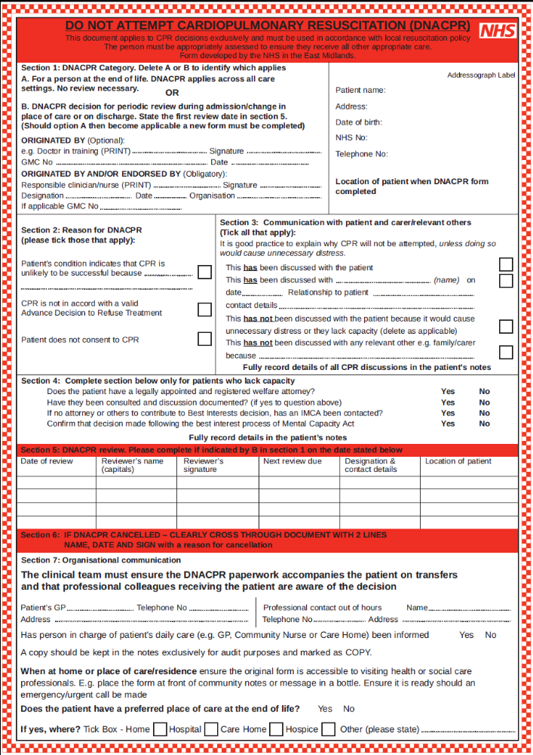
54
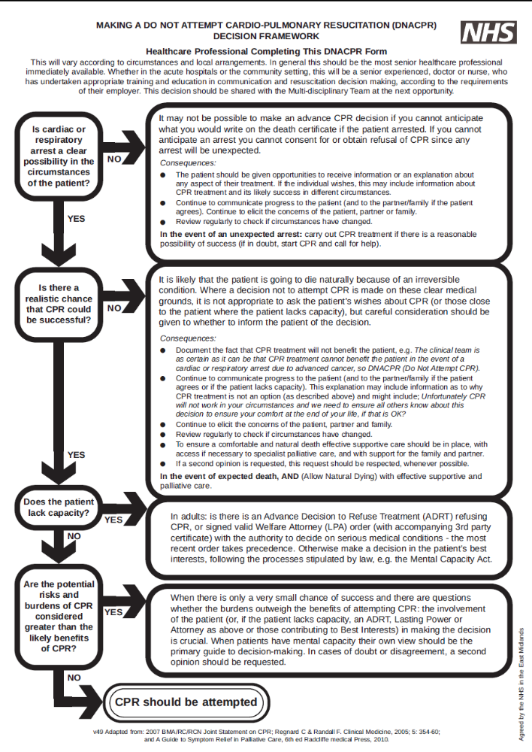
55

Acknowledgements

Many thanks to all those who contributed to the development of this end of life package for adults with learning disabilities.

Leicester Partnership NHS Trust (Learning Disability Community Team, Specialist Palliative Care)
University Hospitals of Leicester (Mr Richard Wong, Consultant Geriatrician)
LOROS (Jane Schofield & Michael Hudson, Liverpool Care Pathway Lead)
Gold Standards Framework Lead (Carol Abbott)
The Hedges Medical Centre - (Dr Charles, GP)
Milligan Court Ltd (Mandy Clayton, Hayley Gee)
Marston Court Ltd (Ben Morrison , Sally Burton)
Vista – Applegarth Care Home (Emma Lee)
End of life Care Practice Trainers (Leics County and Rutland Community Health Services)
Skills for Care Limited (Marie Lovell)
This guide can be made available in other formats and languages if required.

Any comments welcome to
tracey.finnamore@leicspart.nhs.uk (0116 225 5380)
Kristy.Clayton@hotmail.com (07554115501)
Review date April 2014

