New Friends Hall
Heath House Lane
Stapleton
Bristol
BS16 1EQ

Minutes

Present

Rick Robson
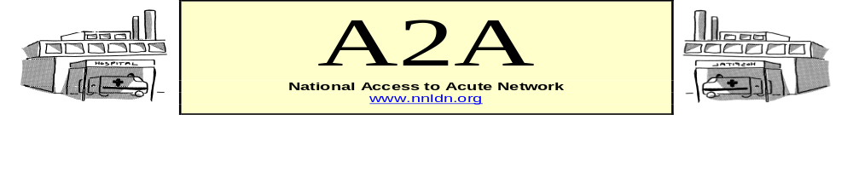

Peter Croughan
Sheryl Gaskell
Louise Hammond
Anne Bowdler
Mary Codling
Jackie Rausi
Simon Shorrick
Liz Jennings
Michelle Garsh
Zoe Gannaway

Apologies

Rose Bollands
Julie Clift
Jeanette Devine
Judith Thorley
Sue Hart
Marriane Duffy
Anne Norman
Lynne Fuller
Ben Thomas
Brenda Byfield
Maria Foster
Karen Breese

_________________________________

1. Introductions

2. Discussions

Discussion about a range of issues took place:

- Information produced by West Midlands A2A & Health Facilitation Networks (posted on NNLDN web pages)

- Accessible information websites
  - www.easyhealth.org.uk (launched 26.04.08)
  - If there are particular projects that you require please enquire directly to Mike Dignon.

- Role and usefulness of uniforms – an interesting concept and debate.
- Business Case drawn up in Reading for Acute Liaison post.

- Zoe talked about the “Hospital Checkers” group in Cornwall set up by herself and Sue Denny. Looked at signage to start with and used “Wayfinder”.

- Simon shared a “Palliative Care Pathway” (unsure who produced it ?BILD).

- Discussed request from Cathy Ross for participants for a DVD on CHD (email with details sent 19.06.08 to all A2A Members).

- Idea shared about use of coloured food trays.

- Conference update – Leaving Indifference Behind (9th September 2008).

Requests for:-

  - Information on Dialysis treatment.
  - Information on Stoma Care.
  - Parents with a learning disability.

(Please send to rick.robson@sssft.nhs.uk ).

Rick to attach:-

  - Resource Pack – Please amend and acknowledge origins (attached)
  - Leaving Indifference Behind Flyer (attached)
  - Good Practice Template (attached)
  - Dementia Strategy Consultation (sent out to A2A Members 20.06.08)

Next A2A Event
9th September 2008 - “Leaving Indifference Behind” Conference
Telford

Future 2008 dates:
17th December
Venue to be arranged

Originator: Teresa Wylie
Telephone – 01743 261181
E-mail: Teresa Wylie@shropshirepct.nhs.uk

