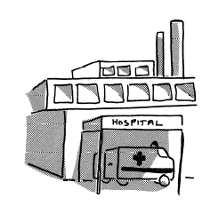

A2A

National Access to Acute Network

www.nnldn.org

Time: 10am –3am
20th June 2007

Venue: Mansion House
Leicester Frith Hospital
Groby Road
Leicester
LE3 9QF

AGENDA

10.00 am Coffee and Tea

10.30 am Introductions, welcome & quick updates.
Rick Robson

11.00 am – 1145 noon Hospital Booklet and A&E Grabsheets Laura Summers and Marianne Duffy

  - Outpatients Pathway Pilot
Marianne Duffy

12.15 noon – 1.15 pm Lunch / networking

BRING YOUR OWN LUNCH

1.15pm – 2.30pm Leicester Hospitals Disability Equality Scheme and PACE Setters project
Deb Baker and Karl Mayes Service Equality Managers UHL

2.30 – 2.45pm Patient Diaries Pilot
Jackie Fleeman

2.45pm – 3pm Any other business

Next Meeting to be held
19th September 2007

Venue to be confirmed

Originator: Teresa Wylie
Telephone – 01743 261181
E-mail: Teresa Wylie@shropshirepct.nhs.uk



